ASSIGNMENT 10:

Name: Om Prasanna Kulkarni

PRN: 22510034

Batch: S3

Branch: CSE

1: Conditional Statements

Write a Python program that takes a user&#39;s input for their age and tells them

whether they are a minor, an adult, or a senior citizen.

Source Code:

age = int(input("Enter your age: "))

if age < 18:

    print("You are a minor.")

elif age >= 18 and age < 65:

    print("You are an adult.")

else:

    print("You are a senior citizen.")

OUTPUT:



2: Looping

Create a program that generates the first N Fibonacci numbers using a while

loop and stores them in a list. N should be taken as user input.

Source Code:

N = int(input("Enter the value of N: "))

fibonacci_sequence = []

a, b = 0, 1

count = 0

while count < N:

    fibonacci_sequence.append(a)

    a, b = b, a + b

    count += 1

print("The first", N, "Fibonacci numbers are:")

print(fibonacci_sequence)

OUTPUT:



3: Functions and Conditional Statements

Write a Python function that checks if a given year is a leap year. The

function should take a year as input and return True if it&#39;s a leap year and

False if it’s not.

Source Code:

def is_leap_year(year):

    if year % 4 == 0:

        if year % 100 == 0 and year % 400 != 0:

            return False

        else:

            return True

    else:

        return False

year = int(input("Enter a year: "))

if is_leap_year(year):

    print(year, "is a leap year.")

else:

    print(year, "is not a leap year.")

OUTPUT:



4: Looping and Lists

Write a Python program to find the sum and average of a list of numbers.

The program should take a list of numbers as input and then calculate the

sum and average of those numbers.

Source Code:

num_list = input("Enter a list of numbers separated by spaces: ").split()

num_list = [float(num) for num in num_list]

total = sum(num_list)

average = total / len(num_list)

print("Sum:", total)

print("Average:", average)

OUTPUT:

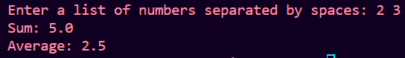

5: Nested Loops and Patterns

Create a program that generates a simple pattern of asterisks. The program

should take an integer 'n' as input and print a pattern of 'n' rows, where each

row contains 'n' asterisks.

Source Code:

n = int(input("Enter the value of 'n': "))

for i in range(n):

    print("*" * n)

OUTPUT:

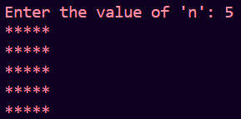

6: File Handling and Conditional Statements

Write a Python program that reads a text file and counts the number of

words in it. The program should ask the user for the file name and then

display the word count.

Source Code:

input_file = "input.py"

output_file = "output.py"

try:

    with open(input_file, 'r') as infile, open(output_file, 'w') as outfile:

        for line in infile:

            if not line.strip().startswith("#"):

                outfile.write(line)

    print(f"Comments removed. The code is saved in {output_file}")

except FileNotFoundError:

    print(f"File not found: {input_file}")

except Exception as e:

    print(f"An error occurred: {str(e)}")

OUTPUT:



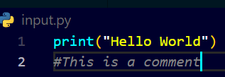

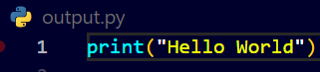

7: Functions and Recursion

Implement a recursive function to calculate the factorial of a given positive

integer. The function should take an integer as input and return its factorial.

Source Code:

def factorial(n):

    if n == 0 or n == 1:

        return 1

    else:

        return n * factorial(n - 1)

n = int(input("Enter a positive integer: "))

if n < 0:

    print("Factorial is not defined for negative numbers.")

else:

    result = factorial(n)

    print(f"{n}! = {result}")

OUTPUT:



8: Conditional Statements and Lists

Create a program that finds the largest and smallest numbers in a list of

integers. The program should take a list of numbers as input and then display

the largest and smallest numbers in the list.

Source Code:

num_list = input("Enter a list of numbers separated by spaces: ").split()

num_list = [int(num) for num in num_list]

if not num_list:

    print("The list is empty.")

else:

    largest = max(num_list)

    smallest = min(num_list)

    print("Largest number:", largest)

    print("Smallest number:", smallest)

OUTPUT:

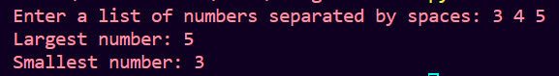

9: Loops and Strings

Write a Python program to count the number of vowels and consonants in a

given string. The program should take a string as input and display the

counts of vowels and consonants.

Source Code:

input_string = input("Enter a string: ")

input_string = input_string.lower()

vowel_count = 0

consonant_count = 0

vowels = "aeiou"

for char in input_string:

    if char.isalpha():

        if char in vowels:

            vowel_count += 1

        else:

            consonant_count += 1

print("Number of vowels:", vowel_count)

print("Number of consonants:", consonant_count)

OUTPUT:

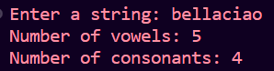

10: Control Flow in a Mini-Project

Create a simple calculator program that allows users to perform basic

arithmetic operations (addition, subtraction, multiplication, and division).

The program should continuously take user input for operations and display

results until the user decides to exit.

Source Code:

def add(x, y):

    return x + y

def subtract(x, y):

    return x - y

def multiply(x, y):

    return x * y

def divide(x, y):

    if y == 0:

        return "Cannot divide by zero"

    return x / y

while True:

    print("Options:")

    print("Enter 'add' for addition")

    print("Enter 'subtract' for subtraction")

    print("Enter 'multiply' for multiplication")

    print("Enter 'divide' for division")

    print("Enter 'exit' to end the program")

    user_input = input(": ")

    if user_input == "exit":

        break

    if user_input not in ("add", "subtract", "multiply", "divide"):

        print("Invalid input. Please try again.")

        continue

    num1 = float(input("Enter the first number: "))

    num2 = float(input("Enter the second number: "))

    if user_input == "add":

        print("Result:", add(num1, num2))

    elif user_input == "subtract":

        print("Result:", subtract(num1, num2))

    elif user_input == "multiply":

        print("Result:", multiply(num1, num2))

    elif user_input == "divide":

        print("Result:", divide(num1, num2))

OUTPUT:

